# ASSIGNMENT COVER SHEET

|  |  |  |  |  |  |  |  |  |
| --- | --- | --- | --- | --- | --- | --- | --- | --- |
| **Course: BSc Computing (SE)** | | | | **Year: 2** | | CSY2027 | | |
| **Group Project** | | **Title: The Design and Development of a Course Management Software System** | | | | | | |
| Date due out: | Date due in: | | Extension date: | | | | | Extension agreed by: |
| **Student Names (List each member of the group)** | | | | | | | **Tutor:** | |
| Student comment, specific request for feedback etc. | | | | | Marker’s General View of the work | | | |

TABLE OF CONTEXT

1. Introduction

1.1 Project Background

1.2 Project Aims and Objectives

1.3 Project Development Methodology

2 Requirements Engineering

2.1 Elicitation Activities

2.1.1 Interview plans

2.1.2 Interview findings

2.1.2.1 Interview - Simon White

2.1.2.2 Interview – Adam Blake

2.1.2.3 Interview – Raj Patel

2,1.2.4 Interview – Mark Williams

2.1.2.5 Additional Client Interview Data/Follow Up Information

2.1.3 Other problem domain research

2.1.3.1 Comparable Software System Review

2.1.3.1.1 Records Management Systems

2.1.3.1.2 Student Records/Information Portal

2.1.3.1.3 Student Records/Information Applications (Mobile Format)

2.1.3.2 Development Relevant Legislation

2.1.3.2.1 Equality Act

2.1.3.2.2 General Data Protection Regulations (GDPR)

2.1.3.2.3 Educational Relevant Legislation

2.1.3.3 Academic Literature Review

2.1.3.3.1 Example Project Relevant Research

2.1.3.3.2 Development Relevant Implications of Research

2.1.3.4 User Group Questionnaires

2.1.3.4.1 Student Experience Questionnaire

2.1.3.4.1.1 Questionnaire Development

2.1.3.4.1.2 Questionnaire Results

2.1.3.4.1.3 Questionnaire Analysis

2.1.3.4.2 Academic Staff Experience Questionnaire

2.1.3.4.2.1 Questionnaire Development

2.1.3.4.2.2 Questionnaire Results

2.1.3.4.2.3 Questionnaire Analysis

2.2 Requirements Specification

2.2.1 Problem Domain Description

2.2.1.1 Existing Business Operation

2.2.1.1.1 Student Life-Cycle

2.2.1.1.2 Personal Tutorial Life-Cycle

2,2.1.1.3 Optional Process 1

2.2.1.1.4 Optional Process 2

2.2.1.2 Summary of existing business limitations requiring resolution and existing strengths.

2.2.2 Functional Requirements

2.2.2.1.1 Records Management Systems

2.1.3.1.2 Student Records/Information Portal

2.1.3.1.3 Woodlands University College Corporate Website

2.2.3 Performance Requirements

2.2.3.1 Records Management

2.2.3.1.1 Speed

2.2.3.1.2 Capacity

2.2.3.1.3 Reliability

2.2.3.1.4 Usability

2.2.3.1.5 Accessibility

2.2.3.2 Student Records/Information Portal

2.2.3.2.1 Speed

2.2.3.2.2 Capacity

2.2.3.2.3 Reliability

2.2.3.2.4 Usability

2.2.3.2.5 Accessibility

2.2.3.3 Woodlands University College Corporate Website

2.2.3.3.1 Speed

2.2.3.3.2 Capacity

2.2.3.3.3 Reliability

2.2.3.3.4 Usability

2.2.3.3.5 Accessibility

2.2.4 Design Constraints

2.2.4.1 Records Management Systems

2.2.4.2 Student Records/Information Portal

2.2.4.3 Woodlands University College Corporate Website

2.2.5 Commercial Constraints (Total Project)

2.2.6 Acceptance Tests (Total Project)

3 System Analysis & Design (Records Management System)

3.1 Preliminary Design Stages

3.1.1 Textual Analysis

3.1.2 Significant Event Analysis

3.1.3 Commands Queries and Constraints.

3.2 Detailed Static System Designs

3.2.1 First Draft BON System Architecture Diagram

3.2.2 BON System Chart

3.2.3 BON Cluster Charts

3.2.4 BON Class Charts

3.3 Detailed Dynamic System Designs

3.3.1 Events Charts

3.3.2 Object Creation Charts

3.3.3 System Scenario Charts

3.3.4 Dynamic Diagrams

3.4 System Database Design

3.4.1 E-R Model

3.4.2 Attribute Listings

4 System Interface Designs

4.1 Draft Interface Designs (Records Management)

4.1.1 Wireframes

4.1.2 System Navigation Diagram

4.1.3 System Screen mock-ups

4.1.4 System Activity Event Diagrams

4.2 Design Revisions (Records Management)

4.3 Heuristic Evaluation (Records Management)

4.4 Draft Interface Designs (Student Records/Information Portal)

4.4.1 Wireframes

4.4.2 System Navigation Diagram

4.4.3 System Screen mock-ups

4.4.4 System Activity Event Diagrams

4.5 Design Revisions (Student Records/Information Portal)

4.6 Heuristic Evaluation (Student Records/Information Portal)

4.7 Draft Interface Designs (Woodlands University College Corporate Website)

4.7.1 Wireframes

4.7.2 System Navigation Diagram

4.7.3 System Screen mock-ups

4.7.4 System Activity Event Diagrams

4.8 Design Revisions (Woodlands University College Corporate Website)

4.9 Heuristic Evaluation (Woodlands University College Corporate Website)

5 System Build and Technical Notes

5.1 Technically Difficult Code Sections (RMS)

5.1.1 Timetable Slot Allocation Routines (Feature)

-- Code Example

-- Annotation

-- Why the example is considered to be technically sophisticated

5.1.2 Feature 2

5.1.3 Feature 3

5.1.4 Feature 4

5.2 On-going Testing Methodology (1-2 Pages)

5.3 Final System Interface Displays

5.3.1 Records Management System

5.3.2 Student University Portal

5.3.3 Mobile Portal

6 Test Strategy

6.1 Overview of Test Strategy - 1 Page

6.2 Sample Test Results – 5-10 pages of example test data.

7 System Evaluation

7.1 Usability Evaluation Strategy

7.1.1 Target Audience Selection/Sample Size Selection

7.1.2 Trial Active Task List Creation/Design

7.2 Initial System Pilot Trials/Results

7.2.3.1 Thinking Aloud (Observations) and Results

7.2.3.2 Post Event Walkthrough (Questions) and Results

7.2.3.3 List of Key System Amendments

7.3 Final System Trial/Results

7.3.1 Usability Questionnaire Design

7.3.2 Final Questionnaire (Used in Trials)

7.3.2 Questionnaire Results – Implications of Results

8. Project Conclusions – 2-3 pages

Typical conclusion content includes

* Strengths and limitations of the project
* Overall success of the project – based on testing and evaluation results.
* Future work – what needs doing next.

9. Project Management

9.1 Project Gantt Chat/WBDS/Activity List

9.2 Project Meeting Minutes

9.3 Project Quality Plan/Strategy

9.4 Project Work Log

10. References

11. Appendix

1. **INTRODUCTION:**

Woodlands University College (WUC) is a small university that offers a variety of degree programs. The Computing Degree at WUC is led by Dr. Simon White, who is also the course leader.

Dr. White, as course leader, has approached our software engineering company and requested that our team look into developing a computerized course management system for the computing degree program. The current system is primarily based on clerical work.

The software that our team develops is expected to be used throughout the institution if it is successful, but we have been asked to create a pilot system specifically for the computing department.

* 1. **Project Background**

This project aims to develop computerized course management process, which currently uses a clerical system to manage the course information. As course leader, Dr. White is responsible for a team of course tutors, several administrative support staff, and the current students enrolled in the course, among other things. All of these key groups will, logically, require computerized records. The pilot system should include some, if not all, of the essential functionality illustrated in Table 1 – Provisional System Functionality, in addition to storing all relevant data on all members of the computing department.

**Table 1 – Provisional System Functionality**

|  |  |
| --- | --- |
| Area | Notes/Essential Functionality |
| Student Records | Create, Amend, Archive, Display, Assign. |
| Staff Records | Create, Amend, Archive, Display, Assign. |
| Course Records | Create Structure, Amend, Display, Delete, Archive. |
| Module Management | Create, Amend, Delete, Archive, Display, Assign. |
| Assignment Management | Create, Amend, Delete, Archive, Display, Assign, Mark/Grade |
| Attendance Records | Create, Amend, Archive, Monitor, Display, Action Poor Attendance. |
| Personal Tutor Management | Create, Amend, Assign, Display, |
| Timetable Management | Create, Amend, Delete, Archive, Display |
| Diary Management | Create, Amend, Display, Prompt, Initiate Automated Action. |
| Report Generation/  Management | Create, Display, Print |

Our software development company has been contacted by the course leader Dr White to learn more about the possibility of developing a software suite product that includes:

* To store all relevant data on all members of the computing department.
* A records management system that will enable the university to efficiently manage important staff, student, and other records.
* Responsive student information portal system.

So, to develop a software as a customer requirement we formed 6 members team named **Acheron** to complete the task and provide our best wireframe design to our customer. However, we need further information regarding the university so we scheduled an interview with several of the members of university to obtain appropriate information about the university.

* 1. **Project Aim and Objectives**

The main aim of this project was to discuss the features and requirements provided by the clients and stakeholders at Workshop and to develop the student record portal, student record application and to transform the existing clerical system into a computerized system. To achieve this requirement, the goal can be set as follows:

* The provided information is examined and comprehend, such as briefings and documentation.
* The various requirements engineering processes provide a clear understanding of the problem domain.
* Gather essential issue domain information and gain a better understanding of the needs through online meetings with clients.
* Make a list of appropriate questions for key stakeholders to ask in order to gain a better understanding of the problem and possible system solutions.
* Create a specification document that contains all of the information and knowledge gained from the requirements specification documentation.
* Conduct design workshops with relevant stakeholders and move the prototype to the next development stage.
* Through a series of consultations and confirmations, implement all of the basic and essential functionalities to meet the client's requirements.
* If necessary, test and evaluate the system with clients.
* Examine the final system before presenting it to the client.

The goal of the project is to ensure that the final version of the software has all of the features and functionalities that the client requires. Because the software is intended to be user-friendly, the following features should be included:

* Attractive and educational
* It should be easy to use and accessible to all users.
* Perfect features like (effective navigation and search box)
  1. **Project Development methodology**

Following the goals mentioned above in this report, our team will take several approaches to develop a powerful and user-friendly system for this project. We will first gain a complete understanding of the problem area by conducting numerous studies. Then, in order to get some inspiration, we'll take a closer look at other systems that are similar to the one we're working on. We'll be able to get a better idea of the expected functional characteristics as a result of this.

We'll go over the laws that govern education, software, and data as well. Then we'll try to figure out what classes and objects are in the system and build a reliable data system for them. Then, based on feedback from stakeholders, we'll design the wireframe and then the UI, with appropriate functional behavior and consistent performance. After we've completed all of those steps, we'll test our results to ensure that everything we've been told is correct and working.

Finally, we will validate all of our work in order to raise its standard. We will validate it in accordance with all applicable laws, and then we will handle our entire solution for our clients.

The project process is divided into phases, as shown in the following figure.

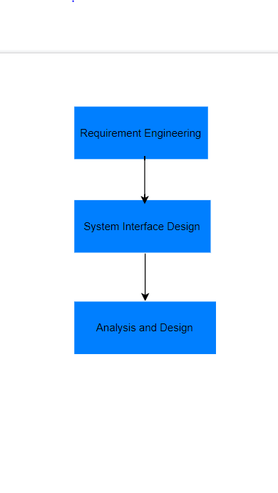

1. **Requirement Engineering:**

Requirement Engineering is the process of investigating and explaining problem areas and requirements, as well as designing and documenting the properties of the solution system that meets these criteria. Various procedures have been provided to assist us in achieving our requirement-gathering goal. Interview strategies, interview outcomes, problem domain description, similar software system review, and formulation of appropriate laws are all examples of elicitation activities. Functional requirements, performance requirements, design constraints, and commercial constraints are also described.

The goal of requirement engineering is to create and maintain a detailed and descriptive document called a "System Requirements Specification." Requirements engineering entails a number of activities in order to create the system. The following are the four steps in the Requirement Engineering process:

1. Feasibility study
2. Requirement gathering (Elicitation)
3. Software requirement specification
4. Software requirement validation

Feasibility study:

* When a client approaches an organization to have a product developed, they usually have a rough idea of what functions the software should perform and what features they expect from the software.
* With this information in mind, analysts will conduct a detailed investigation into the feasibility of the desired system and its functions.

Requirement gathering:

* If the feasibility report indicates that the project can be carried out, the next phase begins with gathering requirements from the user. Analysts and engineers communicate with clients and end-users to learn about their expectations for the software and which features they want included.

Software requirement specification:

* After gathering requirements from various stakeholders, a system analyst creates a document called a software requirement specification.
* SRS specifies how the intended software will interact with hardware, external interfaces, system speed, system response time, software portability across platforms, maintainability, and speed of recovery after a crash. Security, quality constraints, and so on.
* The client's requirements are written in a natural language style. The system analyst is responsible for documenting the requirements in technical language so that the software development team can understand and use them.
* Features for SRS:

The following features should be included in the software requirement specification:

* Natural language is used to express user requirements.
* Technical specifications are written in a structured language that is used within the company.
* Pseudocode should be used to write the description.
* Forms and GUI screen prints in various formats.
* Conditional and numerical documentations for data stream charts etc.

Software requirement validation:

* The requirements method in this document is validated after the requirements specifications are developed. Users may request illegal or impractical solutions, or experts may misinterpret the requirements. If not addressed, this will result in a significant increase in cost. The following conditions can be used to test requirements:

1. If they can be implemented in practice.
2. If they are correct and correspond to the software's functionality and domain.
3. If there are any doubts.
4. When they are completed.
5. If they can be illustrated.
   1. **Elicitation Activity**

Elicitation Activities is concerned with gathering data. It's also known as gathering requirements or acquiring requirements. We gather information from the client about the problem and the problem domain in this stage, create a requirements document, and distribute it to the rest of the development team.

* + 1. **Interview Plans**

We conducted interviews with the following stakeholders.

1. **Dr. Simon White:** The computing course leader.
2. **Mr. Adam Blake:** An experienced course administrator from the computing course program support team.
3. **Dr. Raj Singh:** A senior lecturer, module leader and personal tutor from the computing department.
4. **Mr. Mark Williams:** An existing student enrolled on the computing course

**Dr. Simon White (Course leader)**

* + - 1. What are the major objectives and expectations for new software development?
      2. What is your experience in this field? What strategies do you have in place to help all students achieve academic success?
      3. If possible, could you provide us the course details and other documents so that we may learn more about your previous clerical record management system process?
      4. Do you think this program has a possibility to assist the student, module, and management systems? If so, what are your thoughts?
      5. Why did you choose to partner with us on software development above all those other software companies?
      6. What type of vision do you have for new programs or services in the computer degree field? What new program or service would you like to have that your competitors don't have?
      7. How do you keep track of the number of students enrolled? Do you need help enrolling and managing students?
      8. As a course leader, how do you maintain track of the attendance course tutor, administrative support personnel, and students? Would you want some help utilizing our platform to keep track of them.
      9. What features and behaviors would you want to see on a computerized system to make students and instructors more environmentally friendly and convenient?
      10. What sort of login method do you want for employees and students in this software? Do you want them to register a new account or may they operate using their existing personal account?
      11. How do you guarantee that the course content is delivered consistently and that the course team meets on a regular basis?
      12. How are you engaging with the feedback from the students and course reps?
      13. What is the timeline for the project, in particular for the funding, purchase, implementation, testing of the system and for evaluating the project?
      14. As a whole, I'd want to ask if you have any questions on how the new system should work, and if we missed anything that we should have asked but didn't?

**Mr. Adam Blake (Administrator):**

1. How do you give your students the lecture slides?
2. How do you keep students informed about their evaluations and examinations, as well as the lecture cancellation?
3. What type of submission method would you like for students?
4. How would you want to publish the exam results of students from various modules?
5. How many distinct permission modes should the new system have, and who should have admin power to make user interaction simple and secure?
6. How frequently do you organize internship-related activities for students to assist them grow in their jobs, and how do you want it exhibited or circulated among students in the new system?
7. How do you prefer to provide and evaluate attendance sheets to teachers?
8. What role do you want the new system to play in ensuring that faculty data is shared with other departments and groups as needed?
9. How do you deal with general lecturer queries about procedures?
10. What is your approach to questions about assignment extensions?
11. How do you give lecturers and students miscellaneous mail merges?
12. What kind of program do you run to encourage students to be more interactive and flexible in their fields?
13. Do you want to link the learning platform with new software and have a mobile learning platform as well?

**Dr. Raj Singh (Module leader):**

As a senior lecture & module leader what are your responsibilities?

How does your current management system look like? What kind of changes can be made on your current management system?

What further modifications do you want to see in the system as a senior lecturer? What type of features and design do you want to see?

Do you want your module routines or module Information to be updated daily?

How many courses are there in total, and how did you previously provide the courses and assignments to the students? How would you want to handle everything in the new system?

How would you wish to provide student access? Can your student edit or remove their assignment after it has been submitted?

How do you intend on keeping track of student progress and accomplishment? How do you want this advancement to be shown, and who should have access to award this achievement to the student?

Do you want the program to assist you in notifying the students and tutor about the timetable change?

How do you maintain track of the student's evaluation and course and make it available to them? Who should have access to updated course materials for students, and how would you like this program to assist you?

Would you need any training session for the new system?

What type of communication option would you like to add in a system? (Email, Announcement Page, Discussion board)

Would you like admin powers, and what are your ideas on publishing grades and receiving comments in the management system, and who should have the ability to edit?

Is there anything more you'd want to note, and do you have all of the things you want? If not, what feature would you like to see added?

**Mr. Mark Williams (Student):**

1. What subjects are you presently pursuing and why did you select your university?
2. What aspects of your university education do you love the most?
3. How effective has your current academic training been in preparing you for a future in this field, and what academic goals do you hope to reach by the time you graduate?
4. Have you ever had a disagreement with a professor over your grades or performance evaluations? What were your justifications?
5. What are your thoughts on the clerically based management structure in place here?
6. Have you encountered any issues with the present management system?
7. Do you believe the existing management system is capable of adequately managing the course management process, and if so, why? If not, what changes to the current management system would you want to see?
8. Do you think a software-based system is a viable answer to the existing course management problem?
9. Should developing a modest and simple pilot system that gives the required degree of flexibility and resilience to allow for future expansion assist in the future administration of student, staff, and course data?
10. Is there anything about the existing clerical-based system that you enjoy and wish to see more of?
11. Do you have any previous experience with software-based industrial services?
12. What advantages do you believe the computerized course administration system will bring to the university's future?
13. In what ways do you believe the computerized management system will assist in reducing the workload on the staff and students?
14. What features of the computerized course management system do you believe will be beneficial to the academic atmosphere at the university?
    * 1. **Interview Findings**

Interview Title: Initial interview with Key Stakeholder- **Dr. Simon White**

Interview Date:

Duration: 1 hour

Person in attendance:

* Sushila Timalsina
* Riya Shrestha
* Rovika Gurung
* Rabindra Prasad Joshi
* Siddharth Yonzon Tamang
* Pawan Bhusal

|  |  |  |  |
| --- | --- | --- | --- |
| Stakeholder | Question | | Questions and Client responses |
| **Dr. Simon White (Course leader)** | Sushila 01 | | **What are the major objectives and expectations for new software development?**  Answer:  As things stand now, all work is done through a clerical-based system, which has caused a slew of problems and issues because these systems require a lot of manpower and everything is done manually, there is a lot of room for human error and performance issues. As a result, we're working on a new system to address these concerns.  This new program is expected to help me develop a quality-of-service system, a record management system, and student records (information portal and information applications). The new system should include all of the tutor, student, and other administrative personnel's records, as well as enable students use the new program efficiently. |
|  | Sushila 02 | | **What is your experience in this field? What strategies do you have in place to help all students achieve academic success?**  Answer:  I am in a position where I have 5 years of experience in my field and have encountered several problems and difficulties along the way. So I employed a few of strategies to overcome these problems and challenges. To solve the problem and improve the academic achievement of my pupils, I want them to be aware of new software not only to the students its also for the staffs and tutor of the organization so that they may learn new things from it. This new system is one of the most up-to-date strategies I'll use, so I hope you can meet all of my needs, such as tracking records to eliminate human mistakes, having everything in one place, and aiding me in helping all students improve their academic performance. |
|  | Sushila03 | | **If possible, could you provide us the course details and other documents so that we may learn more about your previous clerical record management system process?**  Answer:  We've given you with course material as well as extra papers to go through. We've also provided you with our requirement documentation so that you may better understand our requirements and devise a solution to meet them. |
|  | Sushila04 | | **Do you think this program has a possibility to assist the student, module, and management systems? If so, what are your thoughts?**  Answer:  Because it is an automated system with functionality that integrates student records, staff records, course records, module management, assignment management, timetable management, and diary management system without any human errors, I believe that this system will benefit all stakeholders, including students, module leaders, and administrators. If we integrate all of these features, we will have a reliable and acceptable system that will assist us in making our job easier and more efficient. |
|  | Sushila05 | | **Why did you choose to partner with us on software development above all those other software companies?**  Answer:  So we chose you based on your previous work, which was identical to ours, and we found that your work reviewing and feedback on your company's software was also superior to that of other firms. That is why we picked your organization for this project since we feel you can grasp our project requirements and satisfy our needs. |
|  | Sushila06 | | **What type of vision do you have for new programs or services in the computer degree field? What new program or service would you like to have that your competitors don't have?**  Answer:  In terms of the goal, this new system will assist us in adding 10 departments to it, as well as providing additional course options and upgrading our learning management system from a paper-based system to the most recent version of computerized system. Students will have a better learning experience and education quality thanks to an online system. The most recent version of computerized system is the key item that our competitor college lacks, and this is what we want our students to have. |
|  | Sushila07 | | **How do you keep track of the number of students enrolled? Do you need help enrolling and managing students?**  Answer:  Student registration is handled by many teams. Yes, I would want this system to aid in keeping track of student enrollment because all of the enrollment processes are documented on papers, and we frequently run into difficulties with this process. |
|  | Sushila08 | | **As a course leader, how do you maintain track of the attendance course tutor, administrative support personnel, and students? Would you want some help utilizing our platform to keep track of it?**  Answer:  Yes, I sincerely hope that this system will keep track of course instructor, administrative support employees, and student attendance. |
|  | Sushila09 | | **What features and behaviors would you want to see on a computerized system to make students and instructors more environmentally friendly and convenient?**  Answer:  In this regard, I am looking forward to a basic yet appealing UI design. I also recommend that you take a look at other similar existing projects for easy and basic UI design, such as Course and edx. |
|  | Rabindra10 | | **What sort of login method do you want for employees and students in this software? Do you want them to register a new account or may they operate using their existing personal account?**  Answer:  For the login procedure, I'd want to suggest that each person create a new account in this system so that we can quickly identify the type of user they are, and we've planned for four types of users.   1. Student 2. Tutor 3. Module Leader 4. Admin   As a result, they must have variable access and functionality depending on their user role. |
|  | Rabindra11 | | **How do you guarantee that the course content is delivered consistently and that the course team meets on a regular basis?**  Answer:  For the time being, I'm focusing on student and teacher feedback in terms of delivering excellent, up-to-date course materials and upgrading them accordingly. |
|  | Rabin12 | | **How were you engaging with input from students and course representatives before this new software, and how do you intend to connect with it now?**  Answer:  Discussing the current situation, we were working on feedback manually, but we were having issues with these manual systems since certain input was not reaching us owing to a variety of issues, such as the loss of paper information.  So, I'd like this program to have capabilities such as giving students three alternatives when delivering feedback. First, comments should be sent to university administration, then to the module leader, and finally, students should be asked if they want their identities exposed or not. |
|  | | Rabindra13 | **What is the timeline for the project, in particular for the funding, purchase, implementation, testing of the system and for evaluating the project?**  Answer:  For now, keep the timetable at 5 weeks. In terms of project funding and cost, once you have completed and are convinced with your delivery of the system, the UAT (user acceptance testing) that you will provide to us will be tested by me, my other staff members, and students, and we will evaluate whether the cost and system you have provided is the best deal for us or not. |
|  | | Rabindra14 | **As a whole, I'd want to ask if you have any questions on how the new system should work, and if we missed anything that we should have asked but didn't?**  Answer:  Finally, from a security standpoint, there are four types of users: tutor, modulator, student, and admin user, which you did not mention in your earlier inquiry. Aside from that, PII data should be protected and only accessible to admin users with access to records. The page might load in 3 seconds or less. These are the non-functional requirements that need to be fulfilled. |

Interview Title: Initial Interview with project stakeholder

Interview Date:

Duration: 1 hour

Person in attendance:

* Sushila Timalsina
* Rovika Gurung
* Riya Shrestha
* Rabindra Joshi
* Siddharth Yonzon Tamang
* Pawan Bhusal

|  |  |  |
| --- | --- | --- |
| **Dr. Raj Singh**  **(Module leader)** | Rabindra01 | **How do you give your students the lecture slides?**  Answer:  We now provide lecture slides to our students through email, but we hope to implement a better learning management system in which the module leader may upload learning resources such as pdf documents, audio, and video, and students can quickly access those items to study. |
|  | Rabin02 | **How do you keep students informed about their evaluations and examinations, as well as the lecture cancellation?**  Answer:  All evaluations and examinations are now conducted on paper, with test schedules published in a calendar and lecture cancellations communicated to students through text message. So, I'm hoping that this new software may help with a diary management system in which important assignment submission dates are displayed alongside the due date in the calendar, and if the due date approaches, you'll be reminded or cautioned based on the number of days left. |
|  | Rabin03 | **What type of submission method would you like for students?**  Answer:  After the teacher has uploaded the questions and learning materials, students should be informed. They should be able to obtain assignment documents, file to  solve and should be able to upload them back to the system. We also want a platform where teachers can post questions, which students may compose and submit in order to take the TCA test. The module leader will then evaluate it, assign grades, and make it public so that students may observe their progress. |
|  | Rabin04 | **How would you want to publish the exam results of students from various modules?**  **Answer:**  The assignment or TCA test will be uploaded in the app after the student has completed it. The module leader will then assess it and post the grade on the app for all students to see. |
|  | Siddhartha05 | **How many distinct permission modes should the new system have, and who should have admin power to make user interaction simple and secure?**  Answer:  As I've given you four different user types: admin, tutor, module leader, and students. There is one more user type, super admin, who has the ability to establish the admin user source with more authority. |
|  | Siddhartha06 | **How frequently do you organize internship-related activities for students to assist them grow in their jobs, and how do you want it exhibited or circulated among students in the new system?**  Answer:  As we have been offering internships to qualified students. Students are usually asked to fill out and submit a form to the administration. We review the submitted application and provide internship recommendations based on the information given. I'd like to conduct this operation online since paper-based paperwork might go misplaced, and I'd like to utilize modern technology to help. |
|  | Siddhartha07 | **How do you prefer to provide and evaluate attendance sheets to teachers?**  Answer:  In the new system, as soon as students enters to the classroom, his/her attendance will get started and once he/she leaves the class, his/her attendance will be marked as end of the session. By this way, we will be able to produce the report that might be useful to the admin, module leader, tutor and as well as the students. |
|  | Siddhartha08 | **What role do you want the new system to play in ensuring that faculty data is shared with other departments and groups as needed?**  Answer:  For that reason, I want inter-departmental communication on the app for students, teachers, administrators, and module leaders so that they may interact with one another. |
|  | Siddhartha09 | **How do you deal with general lecturer queries about procedures?**  Answer:  system for student to ask their questions. Usually, they send email regarding quarries and problems to their respective module leaders. But the disadvantages in this is that once the module leader leaves the organization the quarries and answers are also no more accessible, and it is also one sided the quarries, and the answer only remains with the respected module leader and the one who has asked the questions. As to overcome this problem it would be best if there were a communal place where students could ask their quarries and module leader could answer them and I would stay so all can see. |
|  | Siddhartha10 | **What is your approach to questions about assignment extensions?**  Answer:  Currently we usually provide a discussion session, or they can ask questions via email. But I think It would be better if module leaders get the privilege to comment where the assignment question are kept so the can clarify sections of assignment. If there is a function where you can mention a person like using @ then it will be much better to communicate. As for extension it depends upon Module leader |
|  | Siddhartha11 | **How do you give lecturers and students miscellaneous mail merges?**  Answer:  As for now it is in form of physical form. But we would like it if there were space provided where the respective leaders can submit the lecture slide. It would also be better if there was a system or form where the tutors and module leader could fill it and send it to their respective department. |
|  | Siddhartha12 | **What kind of program do you run to encourage students to be more interactive and flexible in their fields?**  Answer:  As for programs we are currently giving out assignments in the learning management system which requires more interaction and students become for engaged in learning new things. |
|  | Siddhartha13 | **Do you want to link the learning platform with new software and have a mobile learning platform as well?**  Answer:  As for the time crunch, we have right now I would say to keep it outside the scope for now. |

Interview Title: Initial Interview with project stakeholder

Interview Date:

Duration: 1 hour

Person in attendance:

* Sushila Timalsina
* Rovika Gurung
* Riya Shrestha
* Rabindra Joshi
* Siddharth Yonzon Tamang
* Pawan Bhusal

|  |  |  |
| --- | --- | --- |
| **Dr. Raj Singh**  **(Module leader):** | Pawan01 | **As a senior lecture & module leader what are your responsibilities?**  Answer:  As a module leader my main priorities are course contains, assignment, TCA and student feedbacks. First I will have to check the course contain provided by the stakeholders and keeping the course updated for the future and secondly managing the time for assignment and TCA. If tutors and students need any kind of help, I will be there to provide it. |
|  | Pawan02 | **How does your current management system look like? What kind of changes can be made on your current management system?**  Answer:  Currently all we have is a paper-based system. Which is slow and prone to more risk. So having a software system would help making entry’s and keeping everything updated easy and fast. There would be a major changes from current system. |
|  | Pawan03 | **What further modifications do you want to see in the system as a senior lecturer? What type of features and design do you want to see?**  Answer:  For now let’s stick with the same deign that has been told by our senior lecture. |
|  | Pawan04 | **Do you want your module routines or module Information to be updated daily?**  Answer:  In terms of the module, nothing will change. Until anything new is introduced, that is. Whereas, materials for lectures and courses may be updated on a daily basis. |
|  | Pawan05 | **How many courses are there in total, and how did you previously provide the courses and assignments to the students? How would you want to handle everything in the new system?**  Answer:  As for the courses list has been provided to you. All the courses and assignment were provided in physical. Courses should be handled by the management team. Whereas course contain and course materials should be handled by module leader and tutor. |
|  | Pawan06 | **How would you wish to provide student access? Can your student edit or remove their assignment after it has been submitted?**  Answer:  We would like them to be able to submit their work, monitor their grades, provide feedback, and communicate directly with the module leaders. They can submit many times for the assignment, but they cannot alter it after it is submitted, and the last submission is the final submission. When the deadline for submitting an assignment has passed, students will no longer be able to do so, and the links will be closed. |
|  | Pawan07 | **How do you intend on keeping track of student progress and accomplishment? How do you want this advancement to be shown, and who should have access to award this achievement to the student?**  Answer:  There is the diary management functionality, which includes student evaluation and accomplishment. Once the enrollment is happened, then functionality will be included in their portal. Only module leader and course tutor have access to award achievement to the students. |
|  | Pawan08 | **Do you want the program to assist you in notifying the students and tutor about the timetable change?**  Answer:  Definitely it is required. |
|  | Pawan09 | **How do you maintain track of the student's evaluation and course and make it available to them? Who should have access to updated course materials for students, and how would you like this program to assist you?**  Answer:  For that, module leaders and instructors can upload course materials for this purpose. Students will have read-only access, but the module leader and course instructor will have the power to post learning materials. |
|  | Rovika10 | **Would you need any training session for the new system?**  Answer:  Definitely, once it is ready and available in the UAT (User acceptance Testing), then one round of training is required for the internal employees. And ones it gives the green signal, then we’ll go to the production live in the dept level then we’ll go live in other departments. SO, in each phase we’ll have better training sessions and I also want to see training help section in the system itself so that any user can go and see if they need any help. |
|  | Rovika11 | **What type of communication option would you like to add in a system? (Email, Announcement Page, Discussion board)**  Answer:  For now, we can consider in app communication system. So, no communication email or discussion board. |
|  | Rovika12 | **Would you like admin powers, and what are your ideas on publishing grades and receiving comments in the management system, and who should have the ability to edit?**  Answer:  I want the owner to have the ability to edit. The administrative staff is in charge of the student record, while the module leader and course teacher are in charge of the assignments and academic content. As a consequence, individual owners will be able to make changes. Other users, on the other hand, will have a read-only view and will be bound by the job's rights and capabilities. |
|  | Rovika13 | **Is there anything more you'd want to note, and do you have all of the things you want? If not, what feature would you like to see added?**  Answer:  I'm not going to add any more features here to create pressure on your side because of the time constant. So, just stick to the functionality that was specified in the requirements, and you may give the final view depending on the conversation. |

Interview Title: Initial Interview with project stakeholder

Interview Date:

Duration: 1 hour

Person in attendance:

* Sushila Timalsina
* Rovika Gurung
* Riya Shrestha
* Rabindra Joshi
* Siddharth Yonzon Tamang
* Pawan Bhusal

|  |  |  |
| --- | --- | --- |
| **Mr. Mark Williams**  **(Student):** | Rovika01 | **What subjects are you presently pursuing and why did you select your university?**  Answer:  I'm pursuing a bachelor's degree in computer science. So, I picked this institution because it offers excellent teaching staff, a well-managed and flexible timetable, and a high regional and international rating. It has also provided excellent industry exposure, making it easier to get work in the market. |
|  | Rovika02 | **What aspects of your university education do you love the most?**  Answer:  Actually, the institution's educational quality is significant to me, and it is one of the aspects of this university that I admire the most. |
|  | Rovika03 | **How effective has your current academic training been in preparing you for a future in this field, and what academic goals do you hope to reach by the time you graduate?**  Answer:  So, once I've graduated, I'm certain that I'll be able to find work since I've received a lot of valuable knowledge in the course and a lot of practical experience throughout my time at university. |
|  | Rovika04 | **Have you ever had a disagreement with a professor over your grades or performance evaluations? What were your justifications and how do you want new software to assist in it?**  Answer:  There were couple of instance where that kind of scenario happened. To clarify the student first I discussed with the tutor and then I provided the response on a basis of answer sheet, but now I want to give a rubric technique for assigning marks to individual grading. As a result, the issue has been resolved. |
|  | Rovika05 | **What are your thoughts on the clerically based management structure in place here?**  Answer:  It is one of the most inefficient processes in use at the institution, and we want to do rid of it as soon as possible in order to implement a more systematic and reliable management system. The existing system is behind in many aspects and is no longer effective, thus I believe it is best to do rid of it as soon as feasible. It adds no value to the staff, students, or institution. |
|  | Riya06 | **Have you encountered any issues with the present management system?**  Answer:  Yes, I've had several problems with the present system, which is behind in many aspects. The current system is slow and adds little to no value to the university's academic atmosphere, such as course management, course information flow, student and staff data and record management, and other issues with the current management system, such as performance issues, a lot of human errors, time consuming, less student interaction with staff or university and there is no central system repository that has all module details, therefore these are the challenges I faced. |
|  | Riya07 | **Do you believe the existing management system is capable of adequately managing the course management process, and if so, why? If not, what changes to the current management system would you want to see?**  Answer:  The current management system is neither scalable or productive since it is a paper-based system that requires significant adjustments and does not meet the more contemporary and technological demands of students today, which can only be met by a computerized modern system. |
|  | Riya08 | **Do you think a software-based system is a viable answer to the existing course management problem?**  Answer:  Yes, I am confident that the software-based system will solve the current problems that we are experiencing because it is more modern, organized, and requires less space and time than our current system, and it also provides a perfect solution to a problem that we are currently experiencing, namely course management. |
|  | Riya09 | **Should developing a modest and simple pilot system that gives the required degree of flexibility and resilience to allow for future expansion assist in the future administration of student, staff, and course data?**  Answer:  Yes, I am very optimistic that whatever system you have designed and delivered in the initial pilot version, we can test and validate it with a limited user group to ensure user acceptance and then install it for a single department and spread it to other departments if there are no issues. |
|  | Riya10 | **Is there anything about the existing clerical-based system that you enjoy and wish to see more of?**  Answer:  Certainly not. The current management system has generated various problems for students, professors, and the institution, and I see no reason to keep it or to include any of its benefits in the new course management system. The existing system is not organized, extensible, or user-friendly. To keep it running, it demands a lot of hard effort, energy, and room. |
|  | Riya11 | **Do you have any previous experience with software-based industrial services? If that's the case, could you give us your thoughts on the software that will be utilized for the new system?**  Answer:  Yes, I have some software experience, so there is no specific software system that provides functionality for all ten modules, but there are a few systems that include the functionalities partially, so you can refer to some of the applications that provide the functionalities partially, such as kosher, adEZ, and UDV. |
|  | Riya12 | **What advantages do you believe the computerized course administration system will bring to the university's future?**  Answer:  The computerized course management system will be extremely flexible and useful. It will reduce human error while simultaneously enhancing employee and student productivity. It provides Several security systems will be installed. We'll have a secure system, but it'll be more organized and methodical than before. By making data management more systemized and controllable, it will benefit all stakeholders significantly. Students, faculty, and the university are all more engaged. The course administration procedure will be streamlined, and course information between instructors and students will flow more easily and effectively. |
|  | Riya13 | **In what ways do you believe the computerized management system will assist in reducing the workload on the staff and students?**  Answer:  This system will undoubtedly improve the staff's working productivity by adding functions such as an attendance tracking system for students and employees. It focuses more on user experience, which means that the system is simple to use and that finding data and information for a specific person or occasion is much easier and takes less time because the data is organized in a systematic manner, which takes up less space and requires less manual labor from the staff. |
|  | Riya14 | **What features of the computerized course management system do you believe will be beneficial to the academic atmosphere at the university?**  Answer:  I believe that features like an attendance tracking system for staff and students, record management for staff and students, which will make the time-consuming task of finding records on a specific staff or student easier and faster, and a course management system, which will help manage the course and provide students with up-to-date information about the course, will benefit the university's academic environment. It will also improve the user experience for all stakeholders and offer significant value to the academic delivery channel. |

* + 1. **Other problem domain research**

This phase includes research into existing equivalent systems as well as other sources such as related legislation that will aid us in gaining a better understanding of the problem domain. Research is a method of systematically gathering facts and elaborating on a topic while also discovering new information relevant to the topic.

* + - 1. **Comparable Software System Review**

We referenced to a few of the websites in this portion and compared the common plan as well as the functionalities for a university-based site. We did a part of investigate on a few websites, but these websites drew our consideration the foremost.

* + - * 1. **Records Management Systems**

As a motivational website for storing data for our project, we chose the Kingston University, University of Kent and Southampton University. These Universities has kept their data up to date and accurate on their websites.

1. **Kingston University:**

|  |  |
| --- | --- |
| System | Description |
| **Kingston University**  https://www.kingston.ac.uk/ | Kingston University London is a public research university in South West London, England, located within the Royal Borough of Kingston upon Thames. Its origins can be traced back to the Kingston Technical Institute, which was established in 1899. It gained college status in 1992 and was formerly known as Kingston Institute of Technology. Kingston has 16,820 students and a £192 million revenue.  **Home Page View:**  This is the home page of the Kingston University website with features such as a navigation bar, pictures and search box. We can learn more about university, facilities, course, and other topics by using the navigation bar.    **Course records management:**  This is the course management page of the Kingston University. They have added a drop menu bar to choose an undergraduate and postgraduate course. You can also search a course by alphabetical letters. When you enter a course, you are interested in it will display description about course.        **Staff record management:**  This is staff record view of Kingston University. They have stored the information of professor with their respective modules with much more information.    **Events record:**  This is event page view of Kingston University. They add a event that had taken and the future event that is going to take place with date in calendar view. There is a search option bar to search the event. |

1. **University of Kent:**

|  |  |
| --- | --- |
| System | Description |
| **University of Kent**  https://www.kent.ac.uk/ | The University of Kent is a public, semi-collegiate research university in Kent, England. The University received its Royal Charter on January 4, 1965, and Princess Marina, Duchess of Kent, was formally installed as the first Chancellor the following year. The university has a main campus north of Canterbury, which is set in 300 acres (1.2 sq km) of parkland and houses over 6,000 students, as well as campuses in Kent's Medway and Ton bridge and European postgraduate centers in Brussels, Athens, Rome, and Paris. With students from 158 different countries and 41% of academic and research staff from outside the United Kingdom, the University is truly international. It is part of the Santander Network, a group of European universities dedicated to promoting social and economic development.  **Home Page:**  As shown in this image, the navigation provides more information detail and search options for various types of information, making it user friendly even for inexperienced users. Its style and design appear to be quite good and pleasant, and each event and program is promoted in an appealing manner.    Course management:  This is the course management page of the Kingston University. They have added a filter function to choose an undergraduate and postgraduate course, location, study modes and for course option.      Event:  Every Events has been recorded and kept in the site. You can also view a calendar app in site which helps you to know about the event that had occurred in the past days and the event that’s gonna be conducted on upcoming days. |

1. **University of Southampton:**

|  |  |
| --- | --- |
| System | Description |
| **University of Southampton**  https://www.southampton.ac.uk/ | Southampton University is a public research university located in Southampton, England. Southampton is a founding member of the Russell Group of UK research-intensive universities and is among the top 100 universities in the world. The University of Southampton has 14,705 undergraduate students and 7,960 postgraduate students, making it the largest university in the South East in terms of higher education students. The University of Southampton Students' Union provides students with support, representation, and social activities ranging from participation in the Union's four media outlets to any of the 200 affiliated societies and 80 sports. On the main campus, the university owns and operates a sports ground for student use, as well as a sports center.  **Home Page:**  This is the home page of the Southampton University. Even for inexperienced users, the navigation provides more information detail and search options for various types of information, making it user friendly.    **Course management:**  This is course view of Southampton University. The course are listed according to alphabetical letters. You can know about course duration and course description clicking the intersted course. You can also know about the course requirement.        **Staff records:**  This the staff record management view. The university had included the number of staff with their respective roles.      **Events:**  The University had included the picture of all the events which make it unique than the other sites we have compared. It has also differentiated the event of different department in different categories. |

* + - * 1. **Student Records/Information Portal**

1. **Kingston University:**

This is the student information portal of Kingston University. This is made for the student for their personal information from where they can know about the course they are taking, grades scored in every subject and many more information. To login the page you need to have University ID and different method had been created for staff and student to login as you can see in the image.

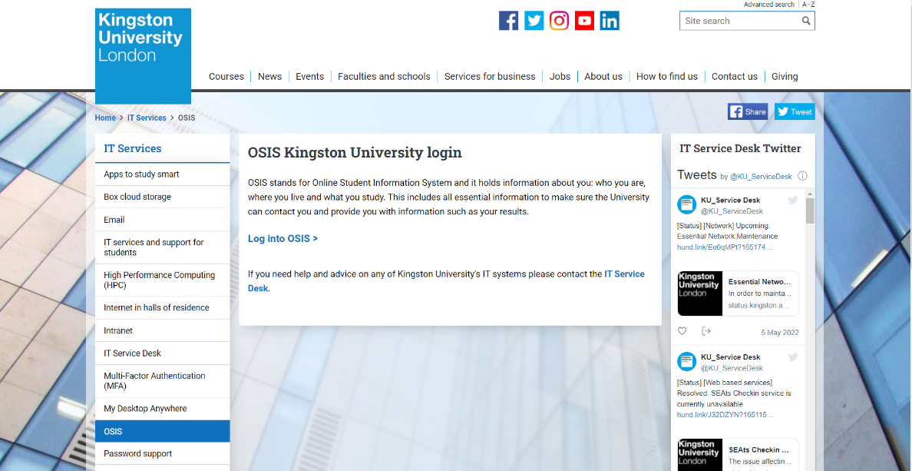

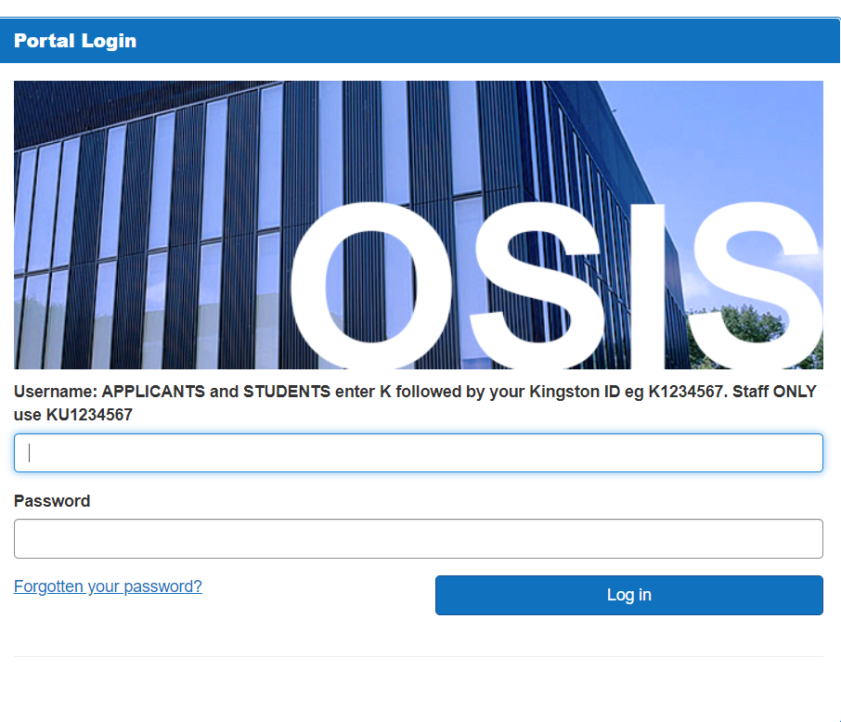

1. **University of Kent:**

This is Kent University's student information portal. This is for the student's personal information, from which they can learn about the course they are taking, their grades in each subject, and much more. To login the page users need college email address.

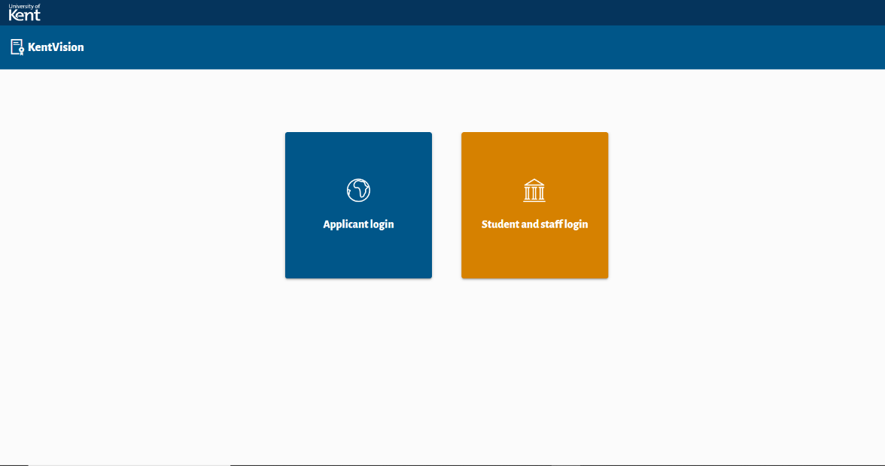

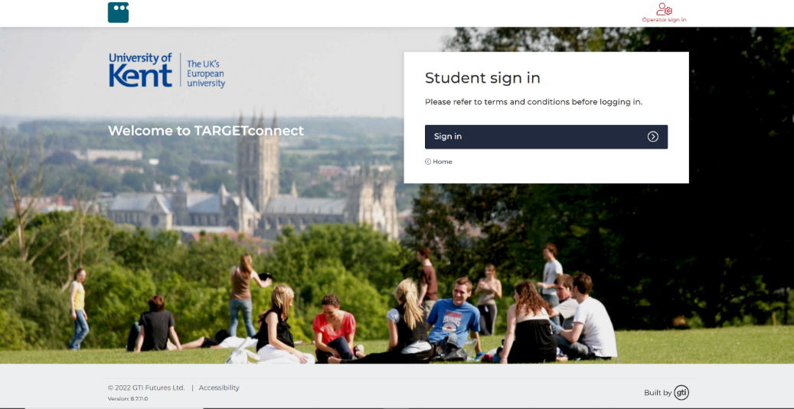

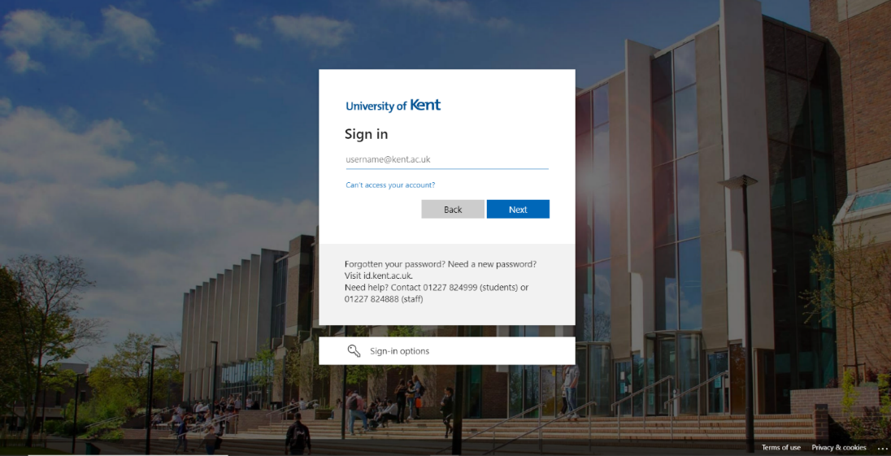

1. **University of Southampton:**

The picture we have displayed below shows the student portal of Southampton University. To login the page you need to get the email address and password from the university after you get enrolled.



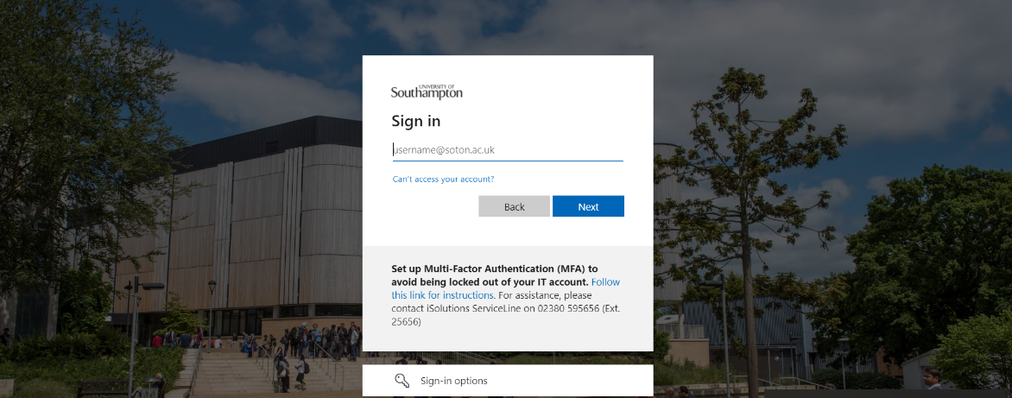

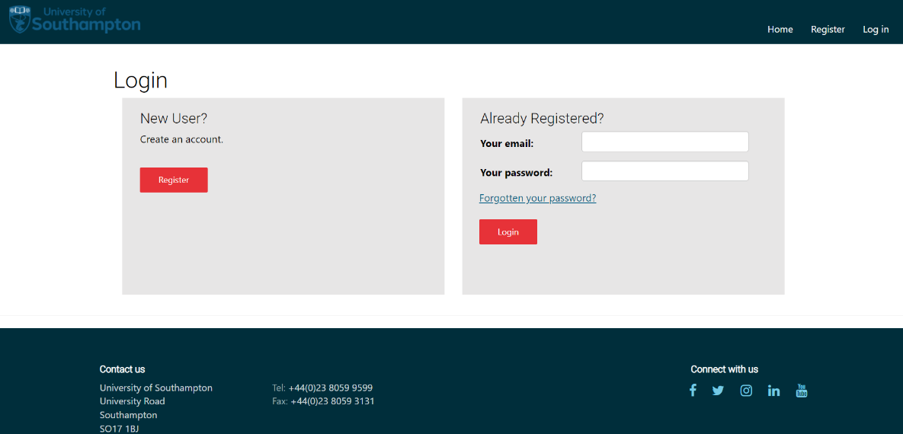

* + - * 1. **Student Records/Information Applications (Mobile Format)**

1. **Kingston University:**

This is the mobile format student portal of Kingston University. You can see a lot of fields being displayed. As you can know about the time management of university through app. You can have Bus timetable with KU bus tracker facility. You can also know about the room number and the floor they are situated in through app.

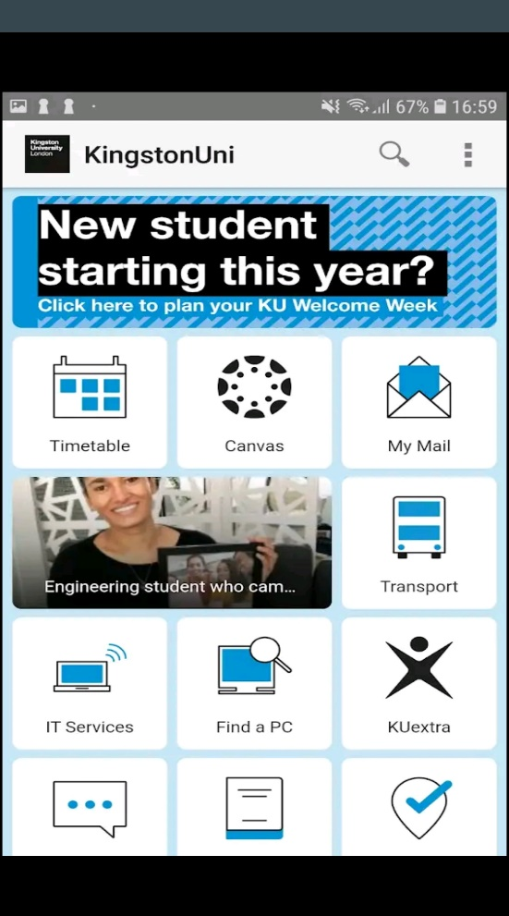 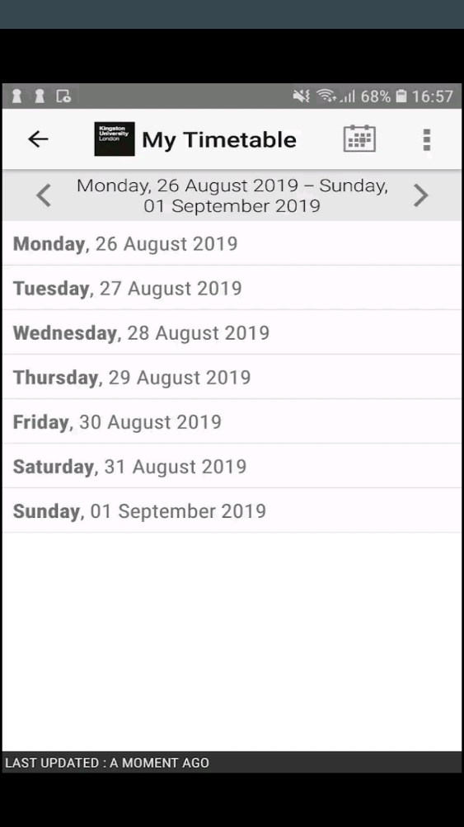

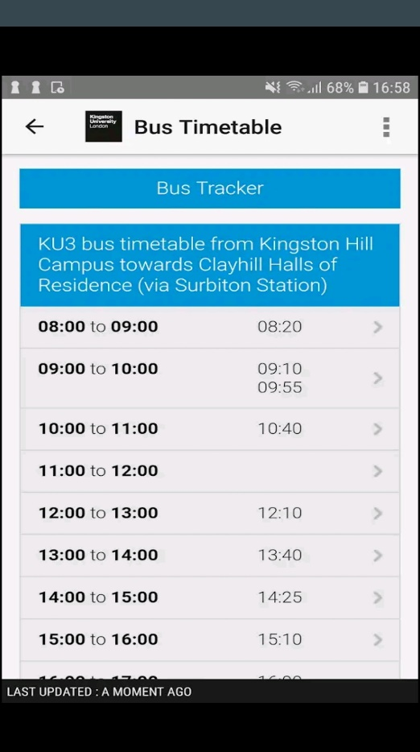 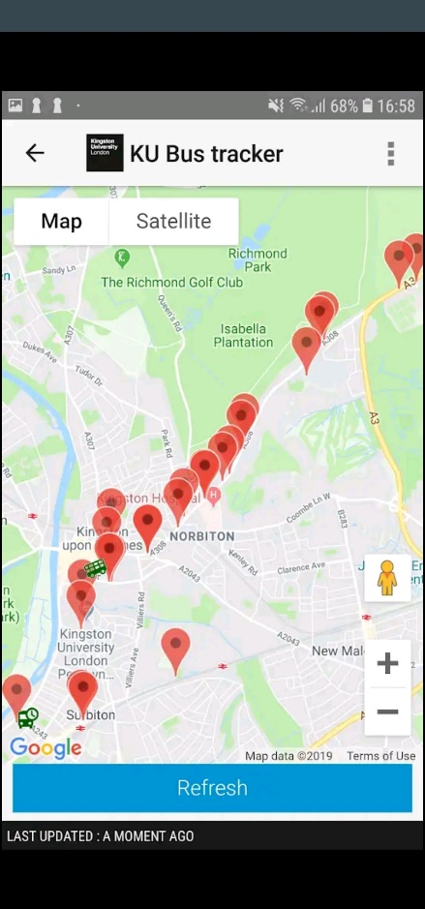

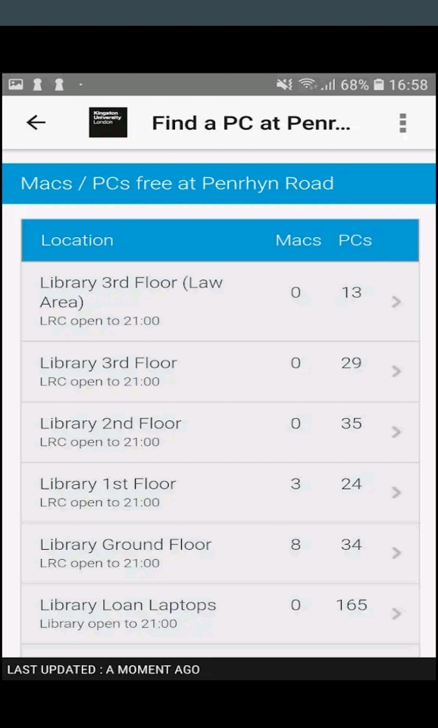

1. **University of Kent:**

This is University of Kent mobile-friendly student portal. Through this app student can know about the time tables of university, course they are enrolled in and the about the events and many more. They can also get the news about the University through the app and connect it through mails and different social sites.

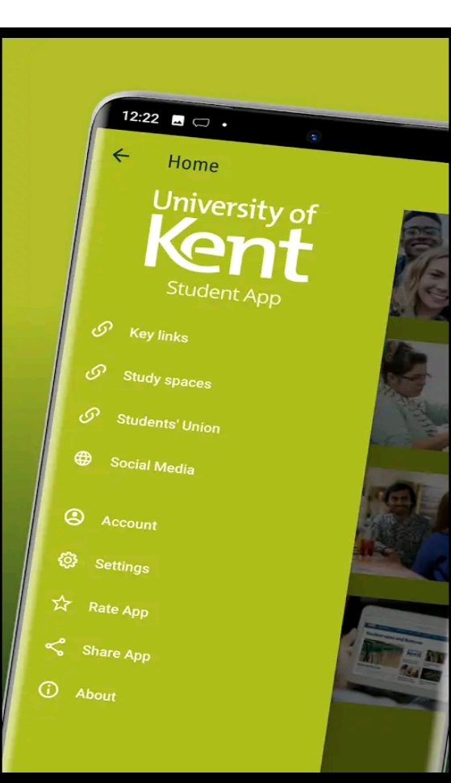 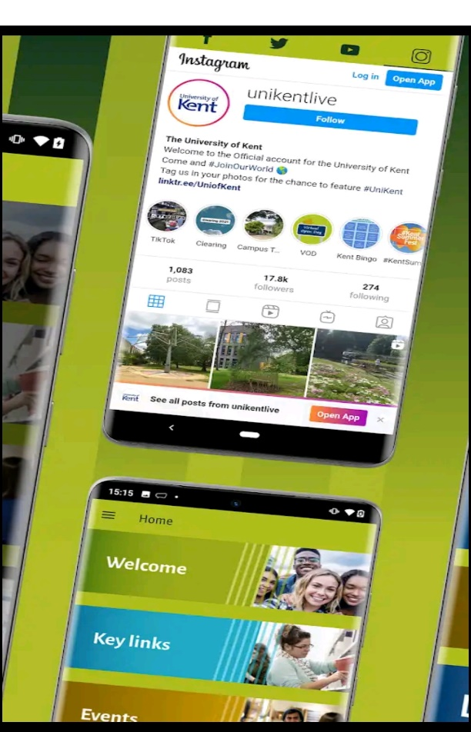

 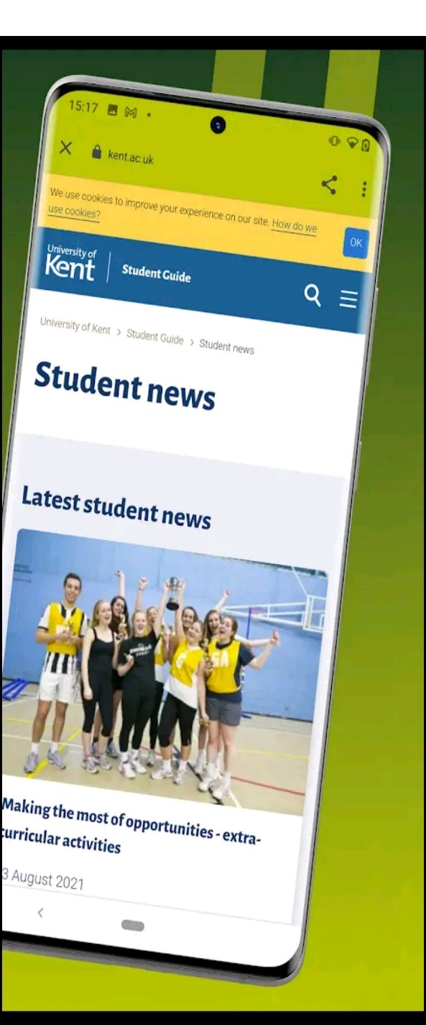

1. **University of Southampton:**

The picture displayed below describes the student portal mobile format view of Southampton University. Through the app student can know about the college premises, bus timetable, sports, news and events.

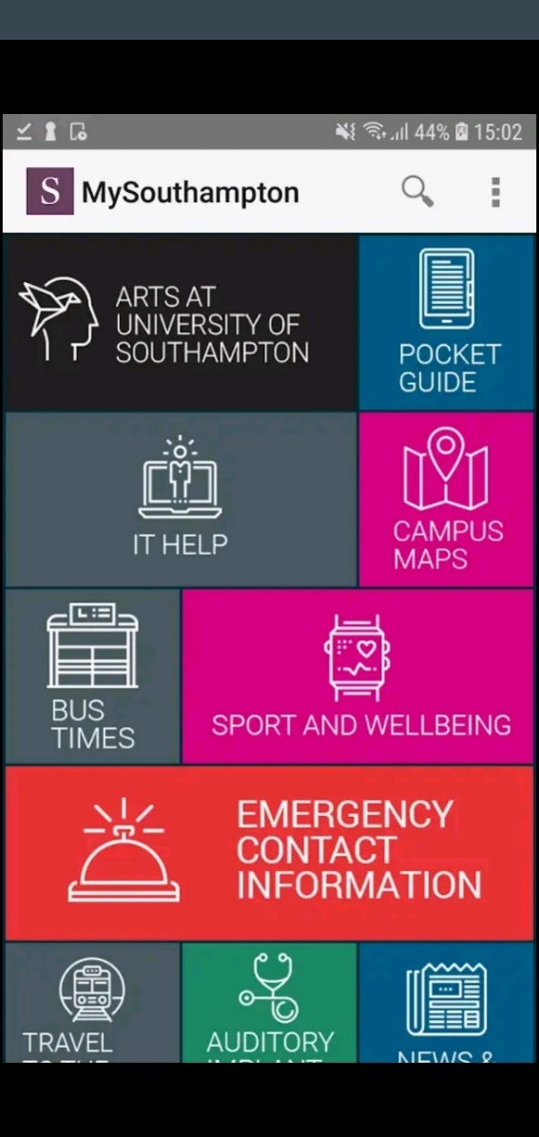 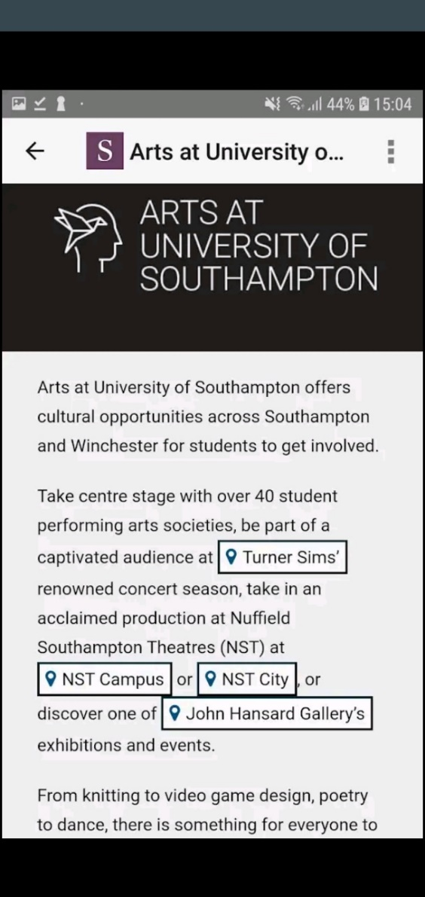

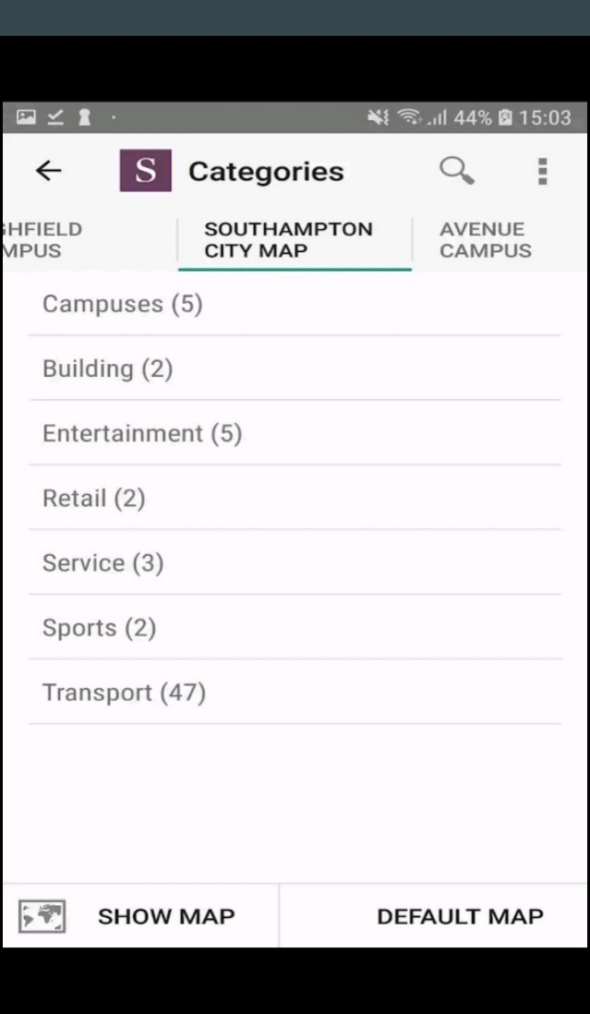 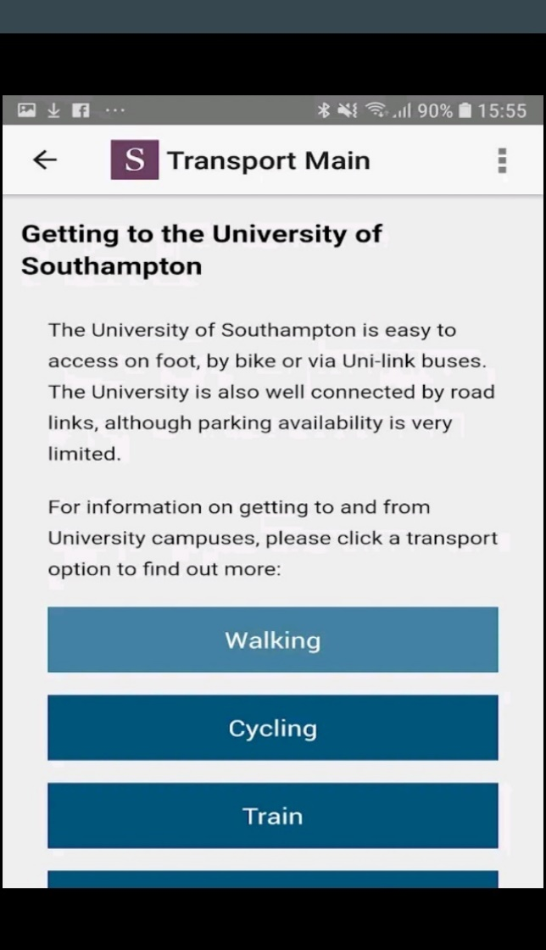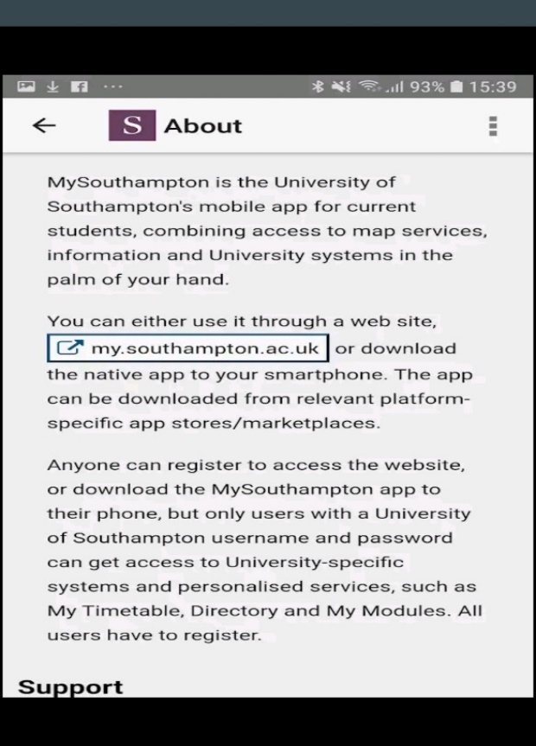

* + - 1. **Development Relevant Legislation**
         1. **Equality Act**

The Equality Act 2010 legally protects people from discrimination in the workplace and society as a whole. It consolidated previous anti-discrimination laws into a single Act, simplifying the law and strengthening protection in certain situations. It outlines the various ways in which it is illegal to treat someone. The following is the policy for using private data stored in the system: (GOV.UK, 2010).

* Allow direct allegations of gender pay discrimination when there is no actual comparison
* preventing pay secrecy clauses from being enforced
* Sex, religion or belief, pregnancy and maternity, and gender reassignment are all protected in private clubs.
* Introduce new authority to the Labour Court to make recommendations that benefit the wider workforce
  + - * 1. **General Data Protection Regulations (GDPR)**

Woodlands University College (WUC) proposed computerized system that contains data on staff, students, and potential members. The information should be used wisely and kept only when absolutely necessary. The Information Assurance Act 2018 establishes rules based on the UK's implementation of the General Data Protection Regulation (GDPR). The following is the policy for using private data stored in the system: (GOV.UK, 2018).

* The use of private data stored in the system should be fair, legal, and transparent.
* The system's private data should only be used for specific, well-defined goals.
* The system should be used in a way that is satisfactory, significant, and limited to only what is necessary.
* Data on the system should be accurate and current as needed.
* Don't keep data on the system for any longer than is absolutely necessary.
* It must be managed in a secure manner, with safeguards against unauthorized or illegal processing, access, loss, destruction, or damage.

According to W3C accessibility evaluation guidelines, the pages should be accessible, navigable, and understandable regardless of any limitations. Individual pages can and must be tested for accessibility using web accessibility evaluation tools.

* + - * 1. **Educational Relevant Legislation**

The federal legislation that oversees the administration of federal higher education program’s goal is to improve our colleges and universities' instructional resources while also providing financial aid to students in postsecondary and higher education. The new system software suggested by Woodland University College (WUC), which holds the student's data and details, should be retained carefully and only when required.

The following is the rule regulating the use of private data maintained inside the system, as stated in the Higher Education and Research Act of 2017:

* It must ensure that the initial registration conditions applicable to an institution
* The institution may access or make arrangements for the assessments
* The length of the period must not exceed the limit specified by the Secretary of State in regulations.
* If the institution has a high-level quality rating at the time the plan is authorized, the higher price will be charged; otherwise, the sub-level amount will be charged.

Academic freedom is granted in terms of determining the content of certain

* + - 1. **Academic Literature Review**
      2. **User Group Questionnaires**
         1. **Student Experience Questionnaire**
  1. How frequently do you visit the school's website?
  2. Is it possible to find what you're looking for on the homepage of the website?
  3. What information are you looking for on the school website?
  4. What online tools do your teachers use to build their classroom websites?
  5. What is your usual method of accessing the school's website?
  6. Would you use a school-related mobile app?
  7. What features would you like to see added to this product?
  8. Do we live up to your expectations?
  9. What level of satisfaction do you have with your experience?
     + - 1. **Academic Staff Experience Questionnaire**

1. What online tools do you use to build the classroom websites?
2. What would you use to describe your current employment situation?
3. What would you say about WUC academics?
4. Do we live up to your expectations?
5. What level of satisfaction do you have with your experience?
6. What features would you like to see added to this product?